EFTP CALCULUS 1

QUIZ 2

Name:

UFID:
Problem 1

- Find an equation of the tangent line to the parabola

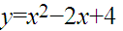

that is parallel to the line
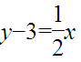

- At what point does the line touch the parabola?

- What is the normal line to the parabola at this point?

- How many times does the tangent line cross the parabola? How many times does the normal line cross the parabola?

- What is the value of the independent variable when the slope of the tangent line is zero?

Problem 2

Consider heat conduction through a wall. The heat transfer through the wall is described by the equation

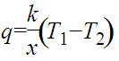
x
x=0
x=L

where q is the heat transfer through the wall, k is the thermal conductivity of the wall, L is the distance into the wall, T₁ is the temperature on the left side of the wall, and T₂ is the temperature of the right side of the wall.

- Assuming that T₂ < T₁, sketch the shape of the graph of the temperature distribution through the wall with respect to the distance x.

- Determine the rate of change of the heat transfer through the wall as a function of x, assuming that all other conditions are not varying.

- Determine the rate of change of the thermal conductivity with respect to the temperature of the left side of the wall.

- Declare whether q increases or decreases in each of the following:

  - k decreases

  - T₂ increases
Problem 3

Take the derivative with respect to x of the following expressions and simplify:

- 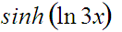

- 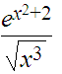

- 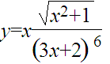

HINT: Use logarithmic differentiation

Problem 4

A water tank consists of two stacked rigid cylindrical tanks. The bottom tank has a length l₁ and radius r₁. The narrower top part of the tank has a length l₂ and radius r₂. Water is being pumped into the tank at a constant rate. In terms of the identified quantities (in the problem description and the figure), determine:
r₂

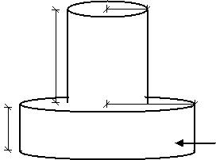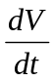
l₁
l₂
r₁
h

- how fast the water level, h, is rising when h < l_{1.}

(b) how fast the water level, h, is rising when h > l_{1.}

